Peanut Butter and Jelly Sandwich

Model INF-m600

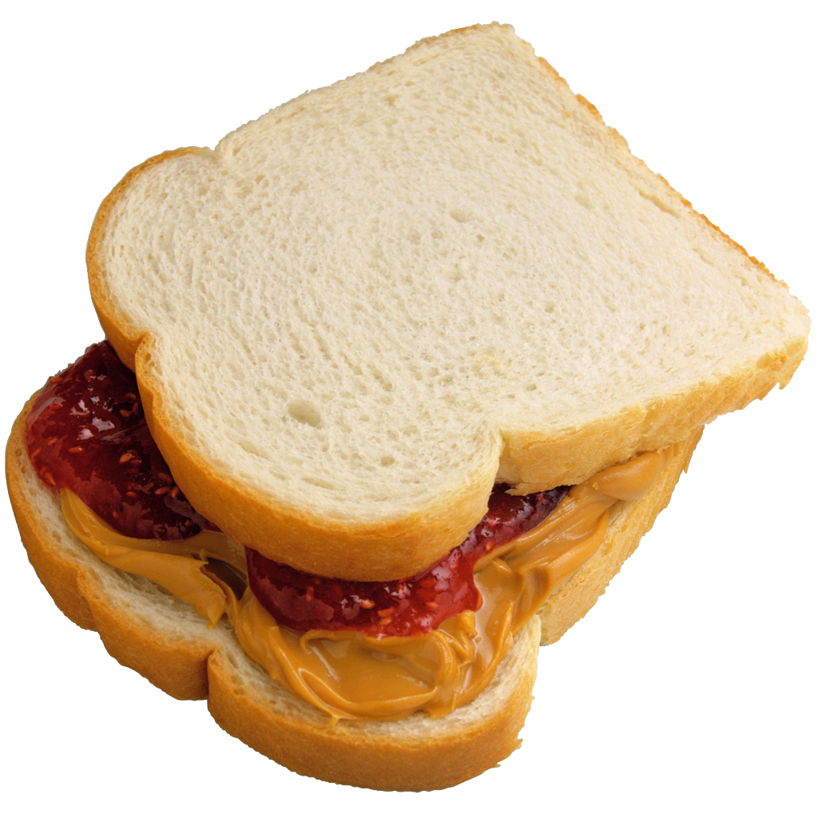

Sandwich. Microsoft Office Clip Art. Microsoft Word for Mac 2011.

Operating Instructions

2018-2019 Edition

System Requirements:

1. Two slices of bread
2. One jar of strawberry jelly (unless you are a monster and prefer grape)
3. One jar of peanut butter
4. Two butter knives
5. One tablespoon
6. One large plate
7. Working space, such as a counter or table
8. Person to assemble the ingredients

Steps:

1. Gather all required materials and place items a-f on the working space. The following steps are for the person assembling the ingredients.
2. Place two slices of bread next to each other on the plate.
3. Open the jar of peanut butter and the jar of jelly.

Note: Both will likely open if one hand is used to hold the individual jar in place and the other hand is used to turn the lid in a counter-clockwise motion, turning until the lid is loose and can be removed. If this does not work, consult other experienced persons in how to specifically open those jars. DO NOT proceed with the remaining steps if the jars are not open.

1. Using your dominant hand, pick up one knife.
2. Hold the peanut butter jar with your non-dominant hand.
3. Insert the knife into the jar of peanut butter. Use a twisting motion of the wrist to remove approximately one tablespoon of peanut butter with the knife.
4. Let go of the peanut butter jar.
5. Holding the piece of bread in place with your non-dominant hand, apply the peanut butter to the face of one piece of bread (see Diagram A).
   1. Start with the knife positioned such that the blade is at roughly a 45-degree from the bread at the end of the slice of bread furthest from you. Lower the knife so that it is close enough to the bread slice that the peanut butter is touching the bread.
   2. Smoothly bring the knife toward you, making sure that the knife does not cut into the slide of bread. Use firm, swift hand movements.
   3. Repeat 8a and 8b until the bread is sufficiently covered, or until you have applied all the peanut butter on the knife.

Note that you do not need to apply all the peanut butter than you have removed from the jar, only enough to satisfy your or the intended consumer’s preferences. If more peanut butter is needed, repeat Steps 5-6 but only remove the amount of peanut butter you think is appropriate (e.g. can be less or more than one tablespoon). If excess peanut butter has been removed from the jar, put it on the side of the plate and/or return it to the jar.

1. Put the knife used for spreading the peanut butter back on the counter.
2. Using your dominant hand, pick up the tablespoon. Hold the jelly jar with your non-dominant hand.
3. Insert the spoon into the jar of jelly. Use a twisting motion of the wrist to remove approximately one tablespoon of jelly with the spoon.
4. Let go of the jelly jar.
5. Transfer the jelly from the tablespoon to the face of the slice of bread (see Diagram A) that does not have peanut butter on it. Tip the spoon to a 45- or 90-degree angle so the jelly slides off the spoon and onto the center of the face of the bread. Use a shaking motion if it does not slide off.

Note that you do not need to apply all the jelly than you have removed from the jar, only enough to satisfy your or the intended consumer’s preferences. If more jelly is needed, repeat Steps 11-12 but only remove the amount of jelly you think is appropriate (e.g. can be less or more than one tablespoon). If excess jelly has been removed from the jar, put it on the side of the plate and/or return it to the jar.

1. Put the tablespoon on the workspace and pick up the non-used knife with you dominant hand.
2. Holding the piece of bread in place with your non-dominant hand, distribute the jelly over the slide of bread with the knife.
   1. Hold the knife such that the blade is at roughly a 45-degree to the bread so it is touching the jelly and use firm swiping motions to move the jelly across the bread.

Note: One suggested pattern is to move slightly less than one-quarter of the jelly from the center of the bread in the direction of each corner of bread (See Diagram B).

* 1. If more jelly is required, repeat steps 10-12.

1. Return the knife to the workspace.
2. Using both hands, pick up the slice of bread covered with peanut butter.
3. Place it on top of the slice of bread covered with jelly such that the jelly side touches the peanut butter side. Do this slowly to ensure the sides of the bread (See Diagram A) of both slices are aligned.

Word Count: 816

